H&M clone(project 2 )

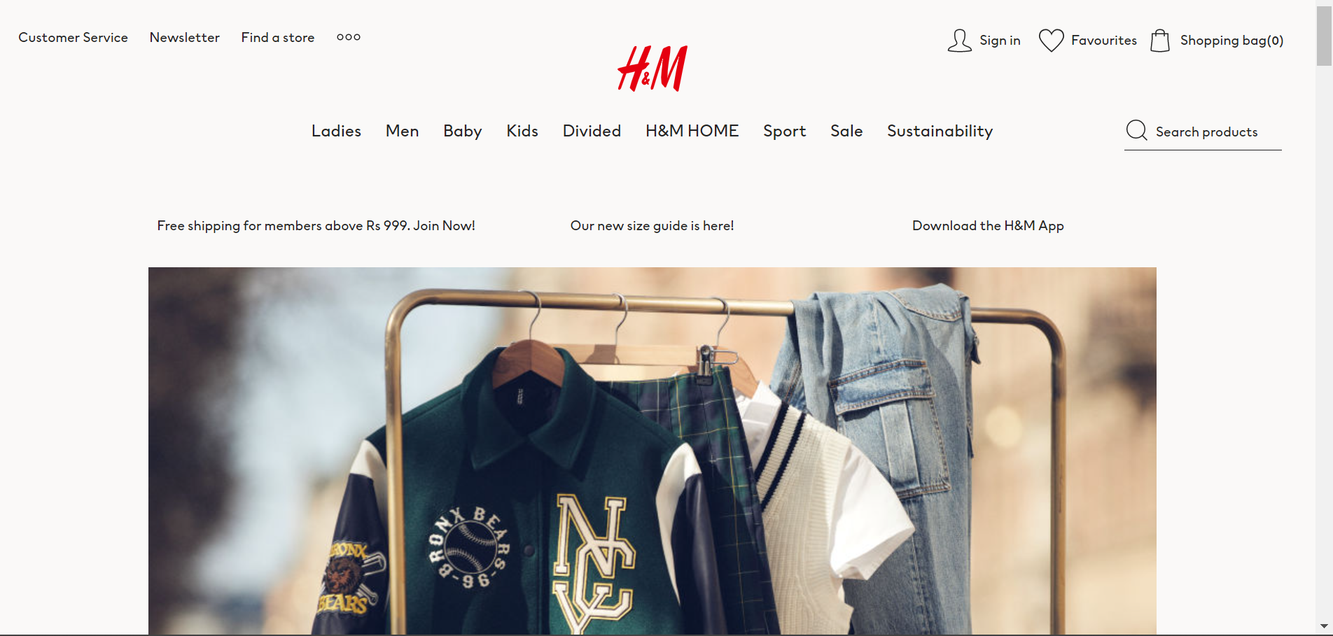

OVERVIEW:

**H & M Hennes & Mauritz AB** or **H&M Group** (abbreviated **H&M**) is a [multinational](https://en.wikipedia.org/wiki/Multinational_corporation) clothing company based in [Sweden](https://en.wikipedia.org/wiki/Sweden). Its focus is [fast-fashion](https://en.wikipedia.org/wiki/Fast_fashion) clothing for men, women, teenagers, and children. As of 2021, H&M Group operates in 75 geographical markets with 4,702 stores under the various company brands, with 107,375[[b]](https://en.wikipedia.org/wiki/H%26M#cite_note-8) full-time equivalent positions.[[7]](https://en.wikipedia.org/wiki/H%26M#cite_note-9)

H&M is the largest international clothing retailer only behind Spain-based [Inditex](https://en.wikipedia.org/wiki/Inditex) (parent company of [Zara](https://en.wikipedia.org/wiki/Zara_(retailer))).[[8]](https://en.wikipedia.org/wiki/H%26M#cite_note-10) H&M was founded by [Erling Persson](https://en.wikipedia.org/wiki/Erling_Persson) and its current CEO is [Helena Helmersson](https://en.wikipedia.org/wiki/Helena_Helmersson).

GOALS:

Home page contains different elements such as



The website consists of different categories such as



The website also contain search bar , wish list and bag icons .

The website is divided into different sections such as trendy categories and new arrival which accommodate new clothing and fashion items for men ,women and kids .

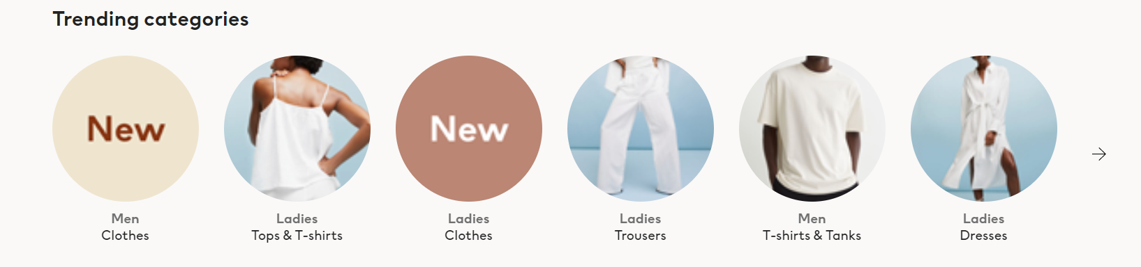

New arrival section

The website also has a blog section where people can talk about new trends .

Website first page ends with

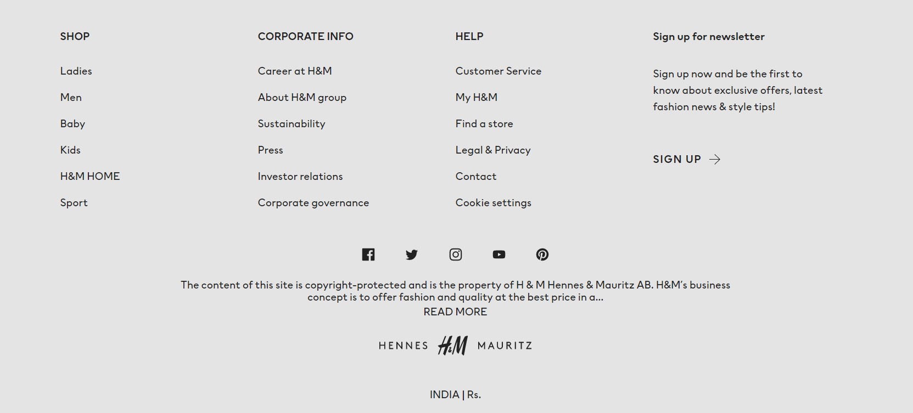

TECHNOLOGIES use in H&M :

   

Thanking you and regards

Pushpinder singh

(edureka student)